**OFFICIAL COORDINATION REQUEST FOR**

**NON-ROUTINE OPERATIONS AND MAINTENANCE**

**COORDINATION TITLE –** 22TDA MOC 14Hydro-Survey of TDA Spillway and Navigation Lock

**COORDINATION DATE -** 12 October 2022

**PROJECT -** The Dalles Lock and Dam

**RESPONSE DATE -** 26 October 2022

**Description of the problem –** As part of the Periodic Inspection at The Dalles Lock and Dam, a hydro-survey of the spillway and downstream approach is needed. The last hydro-survey was conducted in 2018 and due to low tailwater there were data gaps. In reviewing previous hydro-surveys, a minimum Bonneville forebay of 74 feet should provide sufficient tailwater to get full coverage of The Dalles spillway. During the spillway hydro-survey The Dalles north ladder fish entrance will need to be shut down (Wasco PUD shutdown as well) while the survey is north of the 8/9 wall and The Dalles south spillway entrance to the east ladder will need to be shut down while the survey is south of the 8/9 spillwall.

**Type of outage required-**

* **Minimum Bonneville Forebay of 74 feet**
* **Maximum 4-hour outage of the Wasco PUD and North Ladder Fish Entrance**
* **Maximum 4-hour outage of the South Spillway Entrance to the East Fish Ladder**
* **Fish units flow reduced by – 30% to provided criteria for the east and west entrances.**

**Impact on unit priority -** None.

**Impact on forebay/tailwater operation -** None at TDA but requesting a minimum forebay at Bonneville (the request is in the normal range).

**Impact on spill -** Spill operations have finished for the season.

**Dates of impacts/repairs –** Week of October 31st, 2022

**Length of time for repairs** - 0700 to 1500.

**Analysis of potential impacts to fish:**

During the final week October, The Dalles has a 10-year average passage of approximately 1,000 total salmonids a day. Of these fish, approximately 95% use the east fish ladder and of those approximately 80% use the east fishway entrance. The east and west fishway entrance will maintain criteria during this operation. The operation will affect 15% of the total run. The closures will be in 4-hour blocks for each entrance resulting in 30% of the total daylight passage hours.

1. **10-year average passage during the period of impacts.**



Fig 1. The ten-year average passage for all species at The Dalles Dam during the week of 31 October to 4 December (Data from FPC).

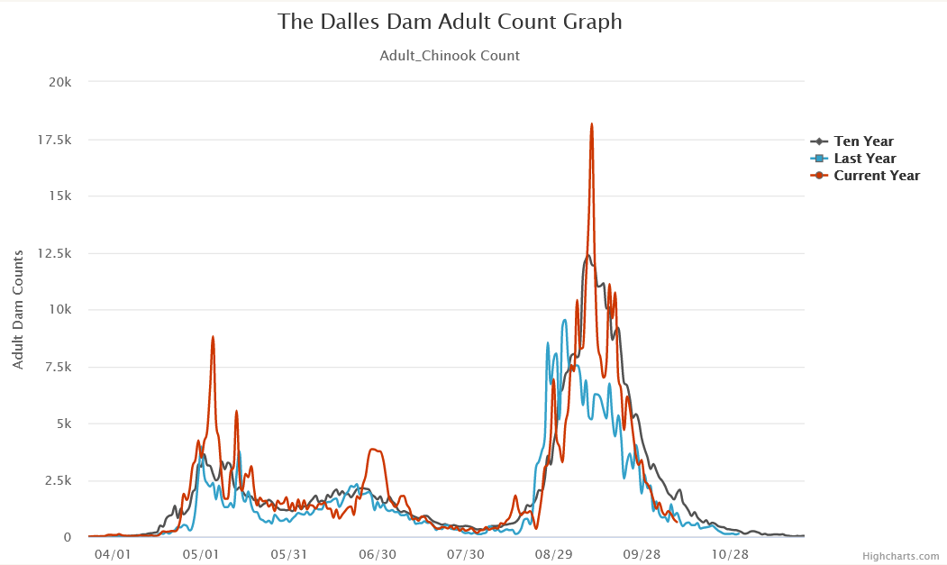

Fig 2. A graph of adult passage at The Dalles Dam. By the time of the operation, most salmonids have passed the dam (Data from FPC).

1. **Statement of the current years run:**

|  |  |  |  |
| --- | --- | --- | --- |
| The Dalles Dam Historical Fish Passage | | | |
| Species | Ten-year average | Current year | Above/Below average |
| Spring Chinook | 113533 | 147118 | Well above average |
| Fall Chinook | 315442 | 2788921 | Below average |
| Coho | 51650 | 48242 | Slightly below average |
| Sockeye | 256662 | 580579 | Well above average |
| Steelhead | 113929 | 93864 | Below average |
| Lamprey | 11277 | 21776 | Well above average |

Fig 3. The current years run at The Dalles Dam compared to the 10-year average (Data from FPC).

**Impacts to upstream migrants (including Bull Trout) by date:**

Some minimal delay may be seen at The Dalles during the maximum 4-hour closures as a result of the operation. However, the east and west fish ladders will maintain criteria throughout the operation and will provide passage. 95% of fish utilize the east fish ladder entrance, this rate may see a slight increase during the survey.

**Impacts to upstream migrants (Lamprey)**

The ten-year average for lamprey passage during this time shows no lamprey passing during this work period. Any affects from the operation are expected to be minimal.

**Impacts to downstream migrants:**

Impacts are expected to be minimal as the majority of salmonid and lamprey juvenile passage has concluded by the date of the operation.

**Comments from agencies:**

**Final coordination results:**

Please email or call with questions or concerns.

Thank you,

Steven Sachs

Fish and Wildlife Field Biologist

Fisheries Field Unit

USACE Portland District

(971) 284-6422

Laurie Ebner

Hydraulic Engineer

CENWP-ENC-HD

Work – 503-808-4880

Cell – 503-250-3404